

Report

Light Following Car

Muzamil Khan **|** 11508

Sameed Ahmed Khan **|** 10121

M.Saad Haleem **|** 10182



**Description:**

Light following car is a car which follows light and travels in the direction from where the light source is coming.

**Circuit diagram:**

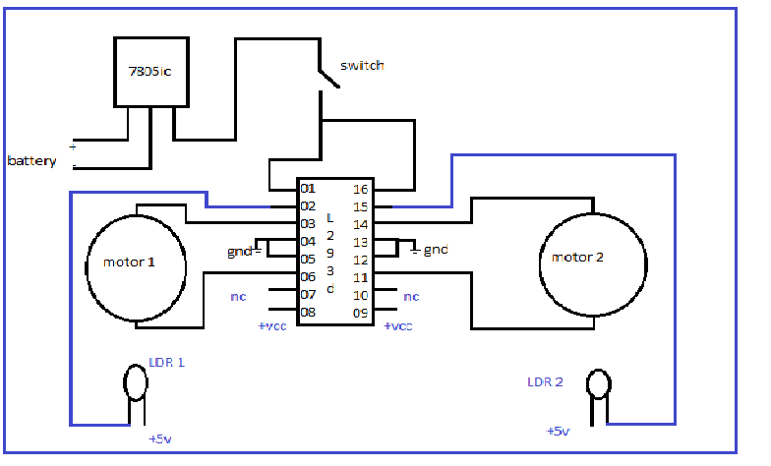

**Components list:**

* LDR Sensors
* 7805 IC
* 7432 IC
* 7408 IC
* 7404 IC
* L239D Motor Driver IC
* Breadboard
* Motors
* Battery 9V

**Description of Components:**

* LDR’s are used to detect the light falling on the robot. One terminal of the diode is to be connected to the +VCC and another terminal should be connected to the input of the L293D IC.
* The L293D is an 16pin IC which is mainly used to drive the motor. Here the motor will run only when the pin2 of L293D IC is 1. The IC is mainly used to drive the motors for robot movement
* One breadboard is used for designing the circuit. The electronic components are connected by inserting it in the holes of the breadboard (or) use a PCB to solder the components.
* It operates on command of the L293D IC. the motor will be activated on the basis of the signal.
* One 9V battery will be sufficient for powering the robot. For more usages, two pairs of 9V battery may be required because the motor will drain the battery very soon.
* One IC 7805 voltage regulator is incorporated for allowing 5v of power supply to the circuit instead of 9v.
* 7432 OR Gates IC for Combinational Logic.
* 7408 NOT Gates IC for Combinational Logic.
* 7404 AND Gates IC for Combinational Logic.

**Working:**

First, we take the LDR’s and check them for their working condition. We are using a battery of 9v hence we need to use a LM7805 IC (5v regulator IC). And we used a switch in order to switch ON and OFF the system. Connect the wheels for motor movements, two wheels at back side and castor wheel at the front side for easy rotation of the robot. Now connect the one terminal of the LDR to the +VCC. And another terminal to the L293D IC. This L293d IC is capable of driving two motor at a time (clock and anti-clock wise). Then connected the L293D IC to the wheels as well to the LDR’s. Switch ON for the operation of the robot.

**Faulty:**

**Ma’am Sana Zafar.**

D L D